Hi Mr. Deepanshu Singhaniya,

Here is your Invoice Summary.

Amount (Rs.)

Jio Mobile Number : Statement Number : Current Plan :

8810570149

342514426620

349 - Prime Rs 0_ SD

## Previous Balance Due

## 411.82

Credit Limit : Rs 675.00 Security Deposit : Rs 450.00 Statement Date : 14-Apr-25

## Payment Received

411.82

: 14-Mar-24

## Current Months Charges 411.82



MAR-24

Due Amount : 411.82 Payment : 411.82

Bill Period

to

13-Apr-25

Connectivity Services Monthly Plan Charges Other Charges Adjustments / Discounts

Platform Services Monthly Plan Charges Other Charges Adjustments / Discounts

Other Credits Taxes

## Previous Balance with RRL

### 349.00

349.00

0.00

0.00

### 0.00

0.00

0.00

0.00

0.00

62.82

## 0.00

### Due Date

: 23-Apr-25

1. Current Balance (i - ii + iii + iv)



JAN-24

Due Amount : 411.82 Payment : 212.18



FEB -24

Due Amount : 411.82 Payment : 411.82

411.82

# Scan & Pay

## Total Payable 411.82

Invoice Plan Details Period

Connectivity Services:

349 - Prime Rs 0_SD 14-MAR-2024 to 13-APR-2025

You can download your detailed tax invoices on MyJio app / jio.com in the invoice history section.

Reach Us: Call 199 from your Jio number | 1800-889-9999 from other networks | [care@jio.com](mailto:care@jio.com)

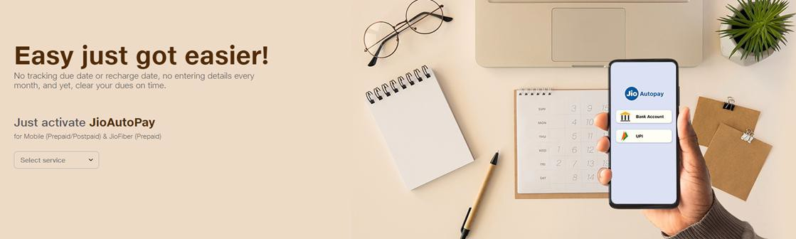Manage your world of Jio with MyJio app or visit [www.jio.com.](http://www.jio.com/)



# or pay via

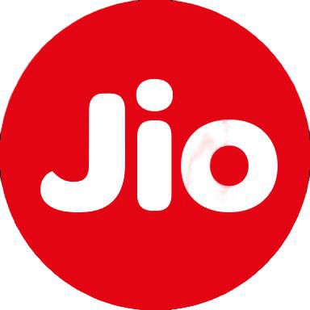

Jio.com MyJio App

# Important Information:

### Payments

* In the event of non-payment, part payment or late payment of the outstanding amount by the due date, Reliance Jio Infocomm Limited (RJIL) and Jio Platforms Limited (JPL) reserves the right to disconnect services.

### Complaints & Service Requests

* You can call 199 (toll-free) from your Jio number or 1800-889-9999 from other networks to register your service request / complaint.
* You can also visit [www.jio.com,](http://www.jio.com/) login with your Jio ID and password; click on "Service Request" option under Profile menu to raise a complaint. To track the status of your existing complaint, use your unique Service Request Number.

### Other

* No charge will be levied for any service without your explicit consent.
* No migration fee is chargeable for changing tariff plan.
* In case you are on an unlimited data plan, post consumption of your allocated data limit, you will experience a downgrade in speed as per Fair Usage Policy.